Premier Metal Storage Buildings Price Sheet (Page 1)

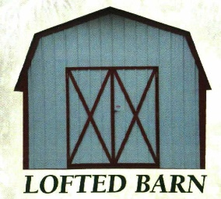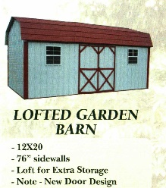
Size Cash Price 36 Month Size Cash Price 36 Month
9x12 $2090.00 $96.75 9x12 $2300.00 $106.48
9x14 $2370.00 $109.72 9x14 $2530.00 $117.13
9x16 $2510.00 $116.20 9x16 $2745.00 $127.08
12x16 $3400.00 $157.41 12x16 $3680.00 $170.37
12x20 $3910.00 $181.02 12x20 $4215.00 $195.14
12x24 $4325.00 $200.23 12x24 $4645.00 $215.05
12x30 $4775.00 $221.06 12x30 $5120.00 $237.04
14x20 $4505.00 $208.56 14x20 $4840.00 $224.07
14x24 $5000.00 $231.48 14x24 $5350.00 $247.39
14x30 $5500.00 $254.63 14x30 $5845.00 $270.60
14x36 $6250.00 $289.35 14x36 $6605.00 $305.79

Premier Metal Storage Buildings Price Sheet (Page 2)

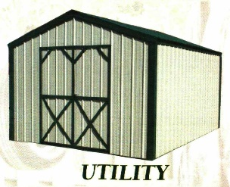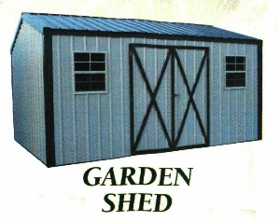
Size Cash Price 36 Month Size Cash Price 36 Month
9x12 $1955.00 $90.51 9x12 $2055.00 $95.14
9x14 $2160.00 $90.74 9x14 $2260.00 $104.63
9x16 $2335.00 $108.10 9x16 $2465.00 $114.12
12x16 $2825.00 $130.79 12x16 $2955.00 $136.81
12x20 $3285.00 $152.08 12x20 $3415.00 $158.10
12x24 $3665.00 $169.68 12x24 $3795.00 $175.69
12x30 $3965.00 $183.56 12x30 $4095.00 $189.58
14x20 $3865.00 $178.94 14x20 $3995.00 $184.95
14x24 $4365.00 $202.08 14x24 $4495.00 $208.10
14x30 $4900.00 $226.85 14x30 $5030.00 $232.87
14x36 $5400.00 $250.00 14x36 $5530.00 $256.02

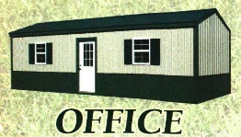
Size Cash Price 36 Month
12x24 $4750.00 $219.91
12x30 $5600.00 $259.26
14x24 $5800.00 $268.52
14x30 $6700.00 $310.19
14x36 $7550.00 $349.54
Premier Metal Storage Buildings Price Sheet (Page 3)

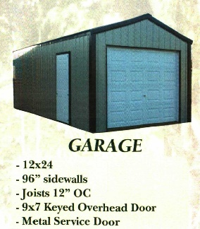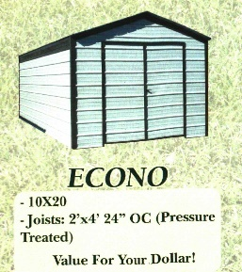
Size Cash Price 36 Month Size Cash Price 36 Month
12x24 $4285.00 $198.38 7x8 $1270.00 $58.50
12x28 $4735.00 $219.21 7x10 $1340.00 $62.04
12x30 $5185.00 $240.05 7x12 $1495.00 $69.21
12x36 $6085.00 $281.71 10x10 $1615.00 $74.77
14x24 $4885.00 $226.16 10x12 $1815.00 $84.03
14x28 $5885.00 $272.45 10x14 $1995.00 $92.36
14x30 $6385.00 $295.60 10x16 $2205.00 $102.08
14x36 $6885.00 $318.75 10x18 $2440.00 $112.96
10x20 $2650.00 $122.69
Standard Features Options
Runners = Treated 4x6 Single Metal Door = $100.00
Floor Joist = 2x4-16” O.C.Econo 24” Double Metal Door = $150.00
Flooring = ¾” T&G Anvantech Single Steel Door = $200.00
Steel Truss Plate Structured Double Steel Door = $450.00
Maintenance Free Metal Siding Single Steel 9 Lite = $225.00
Rafters 2’ On Center Double Steel 9 Lite = $600.00
Windows = $60.00
Insulated Windows = $150.00
Ramps 3x6 = $150.00
Ramp 6x6 = $180.00

